Driveline Assurance

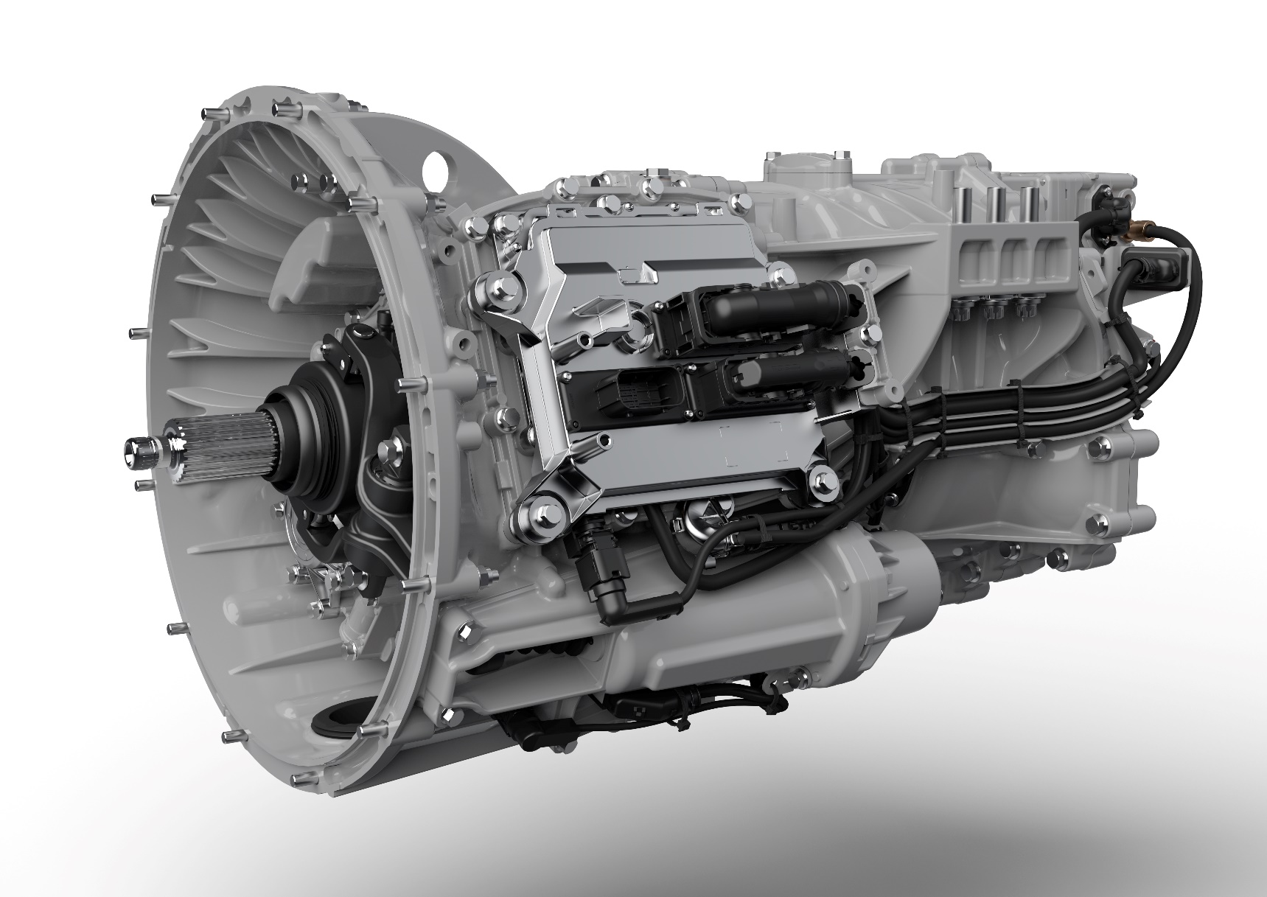

Driveline Assurance

Terms and Conditions

This Driveline Assurance Product applies to selected Scania used vehicles sold on or after 14 April 2022 (Vehicle).

If you identify a Vehicle fault, the Vehicle should be taken to an Authorised Scania Workshop straight away. If the Vehicle has come to an involuntary stop, please contact Scania Assistance who will arrange for roadside assistance.

Your Scania Dealer will make sure your Driveline Assurance Product cover is in place and valid and will carry out any necessary repairs in accordance with the following terms and conditions.

Components Covered

This Driveline Assurance Product protects the components listed in the table below (subject to the exclusions on pages 3 & 4)

Castings: Cylinder block, cylinder head, timing gear cover, gearbox / transfer casting, rear axle housing. Damage as a result of accident, frost or overheating due to drive-on abuse is excluded.

Engine: Flywheel, oil pump, crankshaft, crankshaft bearings and thrust washers, timing gears, camshafts and bearings, cam followers, oil cooler, head gasket, valves and guides (excluding burnt out valves), pistons, piston rings, cylinder liners, con rods, turbocharger. Exhaust brake components (excluding seized units), core plugs, rear main oil seal, front crankshaft oil seal. EGR valve. In the event of the engine having been operated on bio-fuels, the manufacturer’s additional servicing recommendations must have been followed for the item to be covered by this Driveline Assurance Product.

Cooling System: Thermostat, water pump, cooling fan clutch, intercooler, EGR cooler (where applicable), coolant radiator (excluding damaged and corroded units).The engine coolant must be in line with Scania recommendations. Cover excludes all other parts associated with the cooling system.

Fuel System: Fuel supply pumps, SCR doser and pump, EGR control valve and actuator, injector pipes, GAS regulator valve. Nox sensors (T115 & T131) and differential sensor (T141) under fuel system SCR.

Clutch: Clutch cover, release bearing (when subject to mechanical failure). Cross shaft bearings and bushes, master cylinder, servo cylinder, Electronic Clutch Actuation unit.

The clutch disc will be covered for the first 3 months of Driveline Assurance (for general wear and tear) but not if the Vehicle has been driven inappropriately or shows signs of misuse / abuse.

Manual Transmission: Gears, shafts, synchronising units, selectors & bushes (internal), range change, gearbox oil seals. Gear selection control valves. PTO units if fitted from new or by a Scania Authorised Dealer. Cover excludes external linkages and adjustments.

Automatic Transmission: Gears, clutches, torque converter, valve block, oil pump, bearings and bushes. Cover excludes external signals and adjustments.

Propeller Shaft: Universal joints, propeller shaft bearings and transfer box. Cover excludes incorrect operation.

Rear Axles: Crown wheel, pinion, planetary gears, half shafts, pinion bearings, hub reduction gears, hub and pinion seals. Differential locks and mechanism.

Cover excludes incorrect operation or adjustments and hub bearings

Brakes: Compressor.

Steering: Steering pump, Steering box.

Electrics: Electronic control units as listed via Scania diagnostic program and subject to results from testing report. Cover is for COO (E30), EMS (E44), EEC (E67), GMS / TMS (E5), starter motor, alternator.

Cover Period
The duration of this Driveline Assurance Product cover shall be as recorded by the Scania Authorised Dealer on the Driveline Assurance certificate relating to this Driveline Assurance Product (Assurance Period). The Assurance Period will automatically expire on the earliest to occur of (i) the maximum stated distance or (ii) Expiry Date, each as referred to in the Driveline Assurance certificate.

You may have another valid Scania product or service which provides protection for your Vehicle (such as a factory warranty or a Repair and Maintenance Agreement) (Protection Product), which will apply in priority to this Driveline Assurance Product. If your Protection Product would have provided for the necessary repair, but you have exceeded the mileage cap, we can bring the start of this Driveline Assurance Product cover forward. This will provide cover for the repair under these terms and conditions instead of your Protection Product. The Expiry Date of your Driveline Assurance Product cover will also be brought forward, so your Driveline Assurance cover would start and end earlier but run for the same amount of time, unless the maximum distance is reached prior to the adjusted Expiry Date occurring, in which case the cover and Assurance Period will automatically expire.

What the Scania Authorised Dealer will Cover
During the Assurance Period and subject to these terms and conditions, the Scania Authorised Dealer will repair any defect in the Vehicle which is a direct result of defective materials or workmanship in the design or manufacture of the “Components Covered” above.

The Scania Authorised Dealer shall at its own cost carry out such repair or replacement (at the Scania Authorised Dealer’s sole discretion) including dismantling and re-installation (as necessary) to achieve a cost-effective repair commensurate with the nature of the failure and the age and mileage of the Vehicle. The Scania Authorised Dealer may use refurbished parts in any such repair in satisfaction of its repair obligations.

Exclusions
This Driveline Assurance Product will not cover any component not specifically listed as a Component Covered above.
The following exclusions will always apply, and The Scania Authorised Dealer shall not have any obligation to repair or replace, despite being a Component Covered:
- Items covered by Max 24 or other Protection Product;
- Any defects resulting from: road accidents; accidental or natural causes; unsuitable, careless or abnormal use; frost; overheating due to drive- on abuse; overloading beyond maximum weights specified by the manufacturer; inadequate or faulty servicing (including exceeding specified service intervals or criteria, insufficient lubrication, dirt, neglect, acts or omissions of the operator or third parties, use of obsolete parts or accessories) or other similar circumstances or causes;
- consumable items;
- normal wear and tear (such as but not limited to brake linings, clutch drive plates, drive belts, or other items that have reached their end of life due to use such as clutch release bearing, belt tensioner, save for the clutch disc which shall be covered for wear and tear during the first three months of the Driveline Assurance Product cover unless the Vehicle has been driven inappropriately or shows signs of misuse / abuse);
- failures due to any additions or modifications after delivery (save where expressly authorised and warranted in advance by Scania), any broken or modified Scania or supplier seals or settings;
- any non-Scania or inferior quality parts; inadequate third-party service fitment (including bodies or ancillary equipment) or diagnosis;
- failures due to failure to immediately observe any cautions or warnings, failure to carry out immediate repairs (including any emergency or temporary preventative repairs), continuing to use the Vehicle after a fault is or should have been apparent, inadequate precautions in stopping and recovering a Vehicle; and
- failure to promptly notify and present the Vehicle to a Scania Dealer to verify and carry out any repair obligations.

This Driveline Assurance Product does not cover any damages, monies, costs, claims, losses or expenses directly or indirectly incurred in respect of or in connection with the Vehicle or any work done other than as approved at an authorised Scania Authorised Dealer.

What Are My Responsibilities?

You must at all times throughout the Assurance Period ensure that the following conditions are complied with. You must be able (where relevant) to provide us with documents that show you have complied with these terms and conditions. If you are unable to demonstrate full compliance the Driveline Assurance Product will be void and invalidated.

The Vehicle must throughout the Assurance Period:
- be correctly maintained in accordance with Scania recommended maintenance guidelines and schedules, for the relevant operation type and as stipulated in the Driveline Assurance certificate;
- be operated in a legal manner and with due care; and
- be stopped as soon as you (or any operator) notices any defect or fault (e.g. warning lights) so that no further damage is caused.

Policies

Claims and payments will need to be submitted and processed in line with Scania's latest policies and manuals available online or by request.

Foreign Repairs

Repairs under this Driveline Assurance Product may be offered at authorised and participating Scania Dealers outside the UK, subject to local laws and procedures. The terms and rates of this Driveline Assurance Product package will apply, meaning the Scania Authorised Dealer will pay at most what the necessary repair would have cost at a UK Scania Dealership.

Financed Vehicles

If you finance your Vehicle (lease, contract hire or hire purchase) you will still benefit from this Driveline Assurance Product.

First Buyer Only

This Driveline Assurance Product is only available to you as the customer who bought the Vehicle directly from the selling Scania Authorised Dealer. This Driveline Assurance Product does not pass with the Vehicle and will not benefit any person you sell the Vehicle to.

We may consider transferring this Driveline Assurance Product to someone you sell the Vehicle to for the remaining Assurance Period. Please contact the Warranty Department (details below) for more information.

Repairs under this Driveline Assurance Product

Parts that have been repaired or replaced under these terms and conditions will continue to be covered only for the Assurance Period.

Our Liability To You

You shall not be entitled to any compensation or other payment or claims for loss of use, loss of opportunity, loss of profit or any indirect, contingent or consequential losses howsoever arising.

Our maximum liability under this Driveline Assurance Product shall never in any circumstances be greater than the purchase price of the Vehicle.

Nothing in these terms and conditions shall exclude or limit our liability for death or personal injury arising from the negligence or breach of strict statutory duty of the Scania Authorised Dealer. In the event that a sale or supply is legally categorised as a Consumer transaction, the consumer rights as to quality and supply with due skill and care shall not be restricted or excluded.

Jurisdiction

These terms and conditions are governed by English law and are subject to the exclusive jurisdiction of the English courts.

Further Guidance

For more information on your Driveline Assurance Product, please contact West Pennine Trucks Limited on 0161 653 9700 or by emailing usedtrucks@westpenninetrucks.com

